MBA - תואר שני במינהל עסקים עם דגש על חברות עתירות טכנולוגיה

COURSE TITLE:
INNOVATION MANAGEMENT
 |  | 2.0 Credit points | Course Number: 099792
Time:  14:00- 17:30 | Day:  Thursday | Number of weeks:7 | Year: 2022 | Mini-Semester: 5
COURSE INSTRUCTOR:
PROF. MIRIAM EREZ

Telephone: 04-829-4461 |  |  | Room: Bloomfield 411a  Office hours:  By appointment |  | E-mail: merez@technion.ac.il
 |  |  | Teaching Assistant:
 |  |  |  | E-mail :
 |  | https://moodle.technion.ac.il/enrol/index.php?id=2531 |  | Course website:

SYLLABUS

COURSE OBJECTIVES and CONTENT

COURSE BACKGROUND: This course focuses on managing the six-step innovation process in organizations, as shown in the Figure below. In addition, the course will highlight the impact of the echo system on enhancing or inhibiting innovation. We will discuss the exploration-exploitation dilemma of decision-makers in investing in innovation.

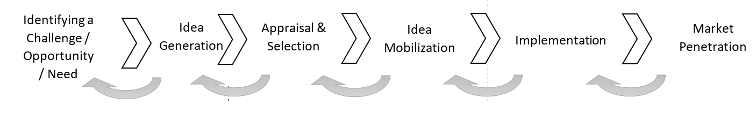
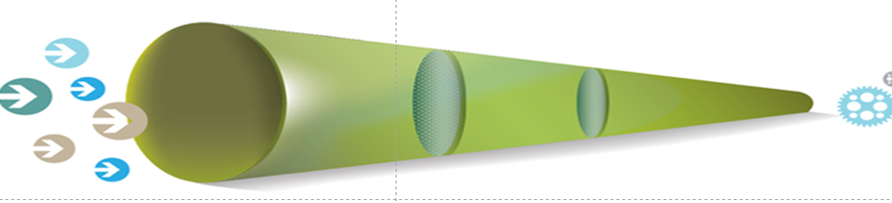

COURSE OBJECTIVES:
The objectives of this course is threefold: (a) Knowledge Acquisition - methods and tools for managing the innovation process in organizations from the first stage of identifying the challenge, problem, or opportunity throughout the entire process towards the final stage of market penetration, reaching the end-users. The course offers relevant tools and methods for each of the six stages.
(b) Highlights the critical role of the echo-system, the organizational structure and culture, and leaders for innovation, considering the leader’s dilemma of taking the risk to invest in innovation (exploration) that may fail or continue to exploit the current operations (exploitation). (c) Implementation: the objective is to analyze the challenges of introducing changes and coping with resistance to change. The course takes an experiential learning approach, namely, students will practice utilizing the method and tools for each phase.

CONTENT & SCOPE: The course content consists of lectures, cases, and exercises for practicing and implementing the methods and tools learned for managing the innovation process. Each class meeting will focus on one phase in the innovation process, including potential decision-making challenges related to innovating and introducing a change.

TEACHING MATERIAL: Teaching materials consist of: class lectures, some readings, class discussions, class exercises to practice the methods and tools learned, and guest speakers.

READINGS: All teaching material (except recommended books) will be available on the course Moodle.

STUDENT ASSESSMENT:
1) Personal Class Attendance: Attendance in 6 out of 7 class sessions.
2) 15% - Active Participation: Reading the course material and actively participating in class discussions. Active participation also consists of actively searching for current examples of innovation in organizations in the daily business magazines and newspaper articles and sharing with the class members.
3) 70% - Final team project (in the form of PowerPoint Presentation). The final project consists of six parts that build upon each other along with the six steps of the innovation process and their integration (each part is 10% of the final project + the integration (10%). Each week the teams of students work on one phase in the process.
Jan 10, 2022: Submission of the first three parts of ideation in the mid-course, Jan. 10. Feedback will be offered.
Feb. 04-10/02/2022: Submission of the final PPT team project +integration

4) 15% - Final presentation of the team project on 04-02-2022 (12 min & 3 min. Q&A).

COURSE PLAN
General recommended readings
- דדי פרלמוטר, מוליכים להצלחה. 2021

Safi Bahcall (2919) Loonshots. How to Nurture the Crazy Ideas That Win Wars, Cure Diseases, and Transform Industries.
בעברית: ספי בקל. (2019) הבלחות. איך לטפח רעיונות פורצי דרך שמרפאים מחלות, מנצחים במלחמות ומשנים תעשיות
3 . Vijay Govindarajan (2016). The three box solution: A strategy for leading innovation. Boston: Mass: Harvard Business Review Press.
(see on Moodle a summary and a video) https://www.youtube.com/watch?v=wgD2VzFqCaE
4. Nathan Furr & Jeff Dyer (2014). The Innovator’s Method: bringing the lean startup into your organization. Boston Mass. Harvard Business Review Press (see Ch. 1 on Moodle)

---------------------------------------------------------------------------------------------------------------

Class 1 (14/07/2022)
- Introduction: Concept clarifications – ACAP, Creativity, Invention, Innovation. Types of innovation and levels of innovation and the Exploration- Exploitation duality (Risk vs. ROI; Change vs. Successful routine ).

- The problem identification phase.
Class Exercise: Challenge/problem/opportunity Identification, the Fishbone Tool.

Reading:
- Christensen, C.; Raynor, M.E. & McDonald, R. What is disruptive innovation? (Dec. 2015). Harvard Business Review. https://hbr.org/2015/12/what-is-disruptive-innovation

- דדי פרלמוטר. מובילים להצלחה. משכל, ידיעות אחרונות. 2021
Recommended
- Sawhney, M., Wolcott, R., and Arroniz, I. (2006). The 12 Different Ways for Companies to Innovate, MIT Sloan Management Review, 47 (3) p.75-82
- Simon Sinek (2009). Start with Why. How great leaders inspire everyone to take action. NY: Portfolio, Penguin. Video: http://www.youtube.com/watch?v=l5Tw0PGcyN0

The team project assignment Part 1 (10%): As a team, 1. select one organization/business for which you would like to develop an innovation project. 2. Identify a central problem in the organization that attenuates its productivity. 3. Analyze the sources of the problem, which appears on the Fish head, using the Fishbone tool.
---------------------------------------------------------------------------------------------------------------

Class 2 (21/07/2022)
- The ideation phase: Individuals and teams’ creative idea generation, in response to the identified challenge/opportunity/need.
This meeting will focus on the types of creative thinking. Students will practice a variety of techniques for enhancing creative thinking as individuals and in teams.

- The idea selection for implementation. Students will learn the criteria for evaluating the idea and estimating its potential success in solving the problem.

Class Exercises: 1. Idea generation - a brainstorming exercise and other tools.
- Idea selection for problem-solving

Reading:
- Amabile, T. (2012). Componential Theory of Creativity (2012) HBS Working Paper, 12-096.
- Dyer, J., Gregersen, H., and Christensen, C. 2009.The Innovator’s DNA, Harvard Business Review, 87 (12), p. 60-67

The team project assignment Part2 (10%): Generate novel ideas in response to the main cause of the problem you identified in the Fishbone. State all your generated ideas and suggest three potential ideas for implementation by order of preferences, with #1 as the most preferred idea and explain why.

---------------------------------------------------------------------------------------------------------------
Class 3 (28/07/2022) -Solution validation

(a) Proof of Concept. Validate your selected idea and demonstrate how it solves the problem. Build a prototype or prepare a plan.

(b) Design Thinking: Validate your solution by testing the product-market fit – MVP, Minimum viable product. Revise the product based on the feedback you get from potential users.

Class exercise: Practicing the Design Thinking method.

Reading:

Brown, T. (2008) Design Thinking, Harvard business review, 2008

The team project assignment Part3: Validate your solution by observing and talking to potential users. Then, please revise and reshape it accordingly.
Submission of the first three parts by August 05, 2022

04/08/2022 NO CLASS (Miriam is in the Academy of Management Conference, Seattle).
----------------------------------------------------------------------------------------------------------------
Class 4 (11/08/2022)

The organization eco-system: Leadership and organizational culture for innovation

Class Exercise Map your organizational culture using the survey tool

Reading:

- Isaacson, W. (June 2012). The real leadership lessons of Steve Jobs. Harvard Business Review.
- Recommended: Miron, E., Erez, M., Nave, E., 2004. Do Personal Characteristics and Cultural Values that promote Innovation, Quality, and Efficiency Compete or Complement Each Other? Journal of Organizational Behavior, 25, p. 175-199.

The team project Part 4 (10 %): Each one of the team members, please analyze the organizational culture of your organization and the likelihood of promoting change and innovation. Consider the organization's strategy of exploration-exploitation and its openness to new ideas and their implementation

---------------------------------------------------------------------------------------------------------------
Class 5 (18/08/2022)

Getting to “yes” when implementing innovation.

Class Exercise: A methodology for implementing change by overcoming resistance to change.

Reading:
- Cialdini, R.B. (2001). Harnessing the Science of Persuasion. Harvard Business Review, 72-79.

Recommended:
- Dutton, J., Ashford, S., O'Neil, R., & Lawrence, K. (2001). Moves that matter: Issue selling and organizational change. Academy of Management Journal, 44 (4), 716-736.

The team project Part 5: Identify sources of support and obstacles for implementing innovative solutions and propose a program for overcoming the barriers.
--------------------------------------------------------------------------------------------------------------

Class 6 (25/08/2022)

Implementing and getting to the user.

Class exercise: How to get to the user and offer the best user experience and added value.

Reading: Sabria,Y, Guido, J.L. Micheli & Nuurb, C. (2018). Exploring the impact of innovation implementation on supply chain configuration. J. of Engineering and Technology Management, 49, 60–75

The team project assignment Part 6: Prepare “the last mile” of getting to the user and offering a unique user experience and added value.

----------------------------------------------------------------------------------------------------------------
Class 7 (01/09/2022)

Presentation of final team project - 12 minutes per team + 3min. Q&As.

Submission of the final project between 02-09-2022 to 08-09-2022

----------------------------------------------------------------------------------------------------------

