SUSTAINABILITY AND IMPACT INVESTING IN GLOBAL BUSINESS STRATEGIES
[Fall/2020]
[Zoom]
[Class Meeting time(s) – lectures, tutorials, lab]

Teaching Staff:
Instructor: Leehe Skuler, Executive Director at the Global Impact Tech Alliance
leehe@the-gita.org phone: 050-7705098
Office Hours: [scheduled + by appointment? Virtual Office Hours?]
TA's: [Name] [Office, e-mail, phone]
Office Hours: [scheduled + by appointment? Virtual Office Hours?]
Credits: [points]
Study hours per week: 2 hours

Course Goals and Description
The primary emphases of this course are a conceptual understanding of sustainability and impact challenges and solutions, and how they are manifested in the private sector. To that end, will we review a number of models in impact investments, analyze how sustainability and impact practices exist within the corporate context, and examine global related trends in “conscious capitalism”, such as consumption, employment, and transparency. A special emphasis will be given to studying the emerging “impact-tech” sector and to learning about leading actors in Israel that can support the process of SDG integration and impact investing. We will learn the theory behind all these issues and then analyze relevant real-world examples.
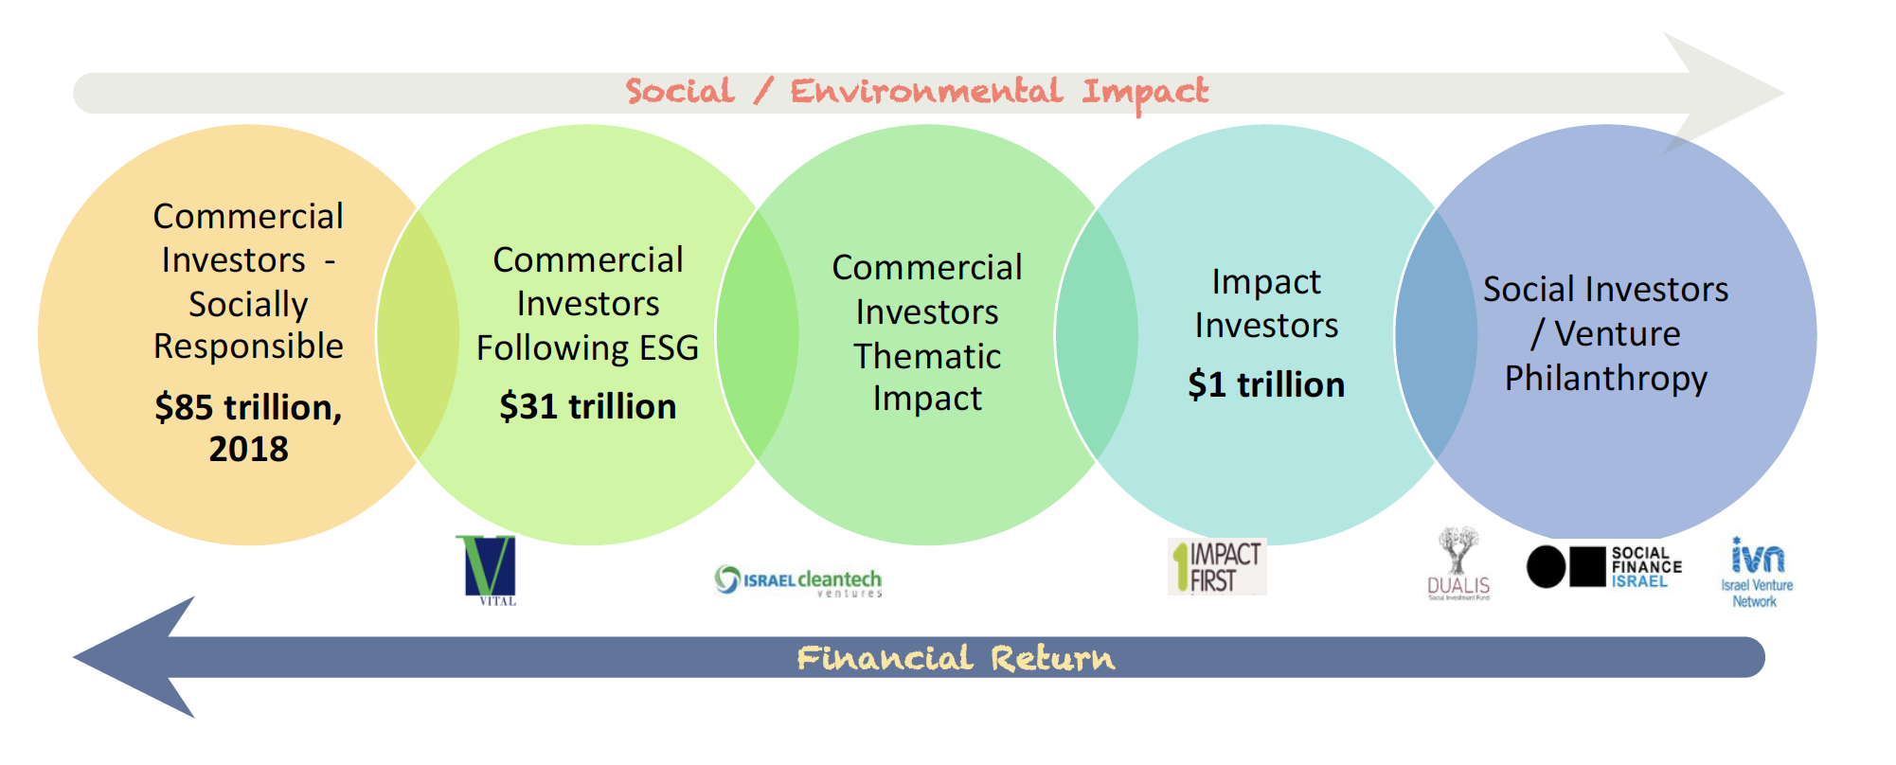

As sustainability solutions, impact investing, and SDG integration become distinct career specializations for finance and business professionals, there is a growing demand for professionals with a strong understanding of strategies and products that address social and environmental challenges while having high financial returns. This course aims to prepare students to careers in sustainability and impact investing by providing the most recent and critical information regarding climate and social challenges, teaching key best-practices and methodologies for sustainability analysis and innovation, and allowing students to practice and implement these methodologies through real-word case studies in their coursework.

Learning Outcomes
This course will teach the mains concepts, trends and processes of integrating sustainability and impact principles in global financial and corporate organizations, with a special focus on the role of tech innovation.
As a result of the course, students will understand the key concepts in impact and sustainability management and measurement, and will be able to integrate the most up-to-date sustainability practices and strategies in corporations and global financial institutions. Students will also understand how to develop and direct technology innovation to address global challenges. Through the assignments, the students will be able to develop an in-depth stand-alone case study on a leading company/investment firm, which will include their research findings, strategic analysis and recommendations.
By creating a deep case-study on a company that has integrated sustainability and impact strategies, students will gain real world insights on building an SDG strategy for global corporate businesses, including integrating innovative technology solutions. Tools include professional impact assessment frameworks, industry research, SDG-strategy building, and implementation tools.

Course Content/Topics

The course content consists of lectures and exercises for practicing and implementing the methods and tools learned for managing sustainability in the private sector. Each one of the seven classes will focus on a key issue, and review analytical and strategic sustainability and impact solutions - which will eventually lead to case study on corporate and financial integration of sustainability practices. The final class will be dedicated to summarizing the issues and the presentation of team-projects.

Assignments and Grading Procedures

- 25% - Attendance and Active Participation. Attendance, course material, interpreting responses to a few self-assessment reviews, and active participation in class discussions. Before some classes, students will be requested to answer 2-3 paragraphs responding to a question related to the readings for the class.
- Attendance in 6 out of 7 class sessions is compulsory and will be monitored;
- 50% - five short team-assignments that at the end of the course will be integrated into the final presentation of a case study and submitted (5% per assignment);
- 50% - Team final report and presentation of the Case Study as the final team project.

Final Project Details
Class assignments and the final project should be completed by students in groups of no more than six and no fewer than two. Each group should submit only one report and presentation, and all group members will receive the same grade on the quality of the final result.

Course Schedule (Topics, assignments, Exams)

Class 1: INTRODUCTION TO IMPACT ECONOMY: A PARADIGM SHIFT
In this class the key concepts, drivers and growth of the sector will be learned, including definitions of sustainability, impact finance, and the Sustainable Development Goals. We will also review an “SDG Diagnostic Tool” to identify key risks and opportunities for the companies to affect global change.

- Reading:
- Mohammed, Amina J. (2015). From MDGs to SDGs: What are the Sustainable Development Goals. SDG Fund

- Team Assignment #1:
The class will divide into teams and select the company for which they would like to develop an SDG strategy case study (from a set list). In the first assignment the team will consider the main environmental and social challenges & opportunities faced by the organization, using the SDG methodologies reviewed in class and submit an initial SDG Diagnosis for the company.

Class 2: DRIVERS OF SUSTAINABILITY URGENCY
In this class we will explore the WHY of the impact economy, review the underlying trends that are putting the sector at the forefront of business strategy - including climate crises, the COVID 19 pandemic, recent trends in consumer patterns (specifically in younger generations), assimilation of values ​​and perceptions of sustainability in society, and failures of the public and philanthropic sectors.

Class exercise:
Impact investing Discussion: we will divide the class into two group - to argue the importance of shareholder value vs and stakeholder value as the key objective of a business.
- Reading:
- Codd, Emma (2020). The Deloitte Global Millennial Survey 2020: Millennials and Gen Zs Hold the Key to Creating a “Better Normal”. Deloitte Global.
- Team Assignment #2:
Analyze the motivations, risks and opportunities for the selected corporation to adopt an SDG and sustainability strategy. Consider the costs, financing opportunities, market opportunities, and required capacity. The assignment can be presented through a SWOT analysis model.

Class 3: IMPACT INVESTING AND SUSTAINABLE FINANCE

In this class we will learn about the dramatic changes in global financial markets, integrating long term environmental and social impacts in financial operations. We will also review key actors and learn about their investment process and impact due diligence across all financial vehicles. we will also delve into partnering with social organizations and understand oh how to do design effective partnerships - through case studies and examples.

- Reading:
- Iarossi Giuseppe, Gregory Neil and Lankes Hans Peter Lankes (2020). Creating Impact: The Promise of Impact Investing. The World Bank International Finance Corporation
- Team Assignment #3:
Conduct research on impact investments trends and sectors related to your case-study company. Identify a leading impact investor that may be a potential funder for your case, and provide a presentation of: fund investment thesis, fund geographic and sector focus, fund impact strategy, measurement methodology, flagship portfolio companies.

Class 4: INTEGRATING SUSTAINABILITY IN CORPORATIONS: From Shareholder value to Stakeholder value

This class will examine the aspects of a comprehensive sustainability strategy for the private sector. We will learn how to integrate corporate objectives, while examining the short-terms and the long term regarding all stakeholders priorities, and how to conduct comparative research to address trends that are occurring around the world. Examples of the whole spectrum: from CSR to active social/impact integration. We will also look at various successes and failures that have taken place in the field.

- Reading:
- Hoffman, Andrew (2018). The Next Phase of Business Sustainability. Stanford Social Innovation Review
- Team Assignment #5:
Design and present a strategic model for the case-study that can maximize both business and sustainability objectives.

Class 5: ENSURING SUSTAINABILITY & MEASUREMENT PRACTICES
As the ability to collect real time, complex data has grown, so have the tools and frameworks of corporate and social actors to assess and measure their impact. This class will review social innovation process and methodologies accepted by impact investors, and mission-driven companies, and explore technology solutions which support this project.
- Reading:
  - Eibhlín Ní Ógáin (2015). Impact Measurement in Impact Investing Learning from Practice. Nesta Impact
  - Creative Commons Impact Management Project (2018). A Guide to Classifying the Impact of an Investment. Impact Management Project https://impactmanagementproject.com/wp-content/uploads/A-Guide-to-Classifying-the-Impact-of-an-Investment-3.pdf

- Team Assignment #5:
Analyze and present your selected corporations impact thesis - theory of change, social innovation strategy, sustainability practices and monitoring methods to ensure they maximize change. Discuss key challenges and potential gaps you identify.

Class 6: Innovation and Impact Tech
In this lesson, students will learn about the growing field of “Impact-tech”. We will examine how technology innovation and start-ups can contribute to the global challenges and which tech companies and investors already operate in the field. We will look at how the sector has developed in recent years and what is happening now, especially in Israel. We will examine an overall view of all existing resources, exposure to important Israeli players, and test cases of sustainable corporate activity. innovation

- Reading:
  - Melina Sanchez (2019). Impact Tech VC Landscape. Techcrunch and Impact 1st Investment https://impact1st.com/wp-content/uploads/2020/04/Impact-Tech-VC-Landscape-2019_Final.pdf

- Class Assignment:
Brainstorming and ideation exercise for development of impact tech solutions, based on design thinking and SIT methodologies.

- Team Assignment #6:
Analyze impact technologies available on SNC Finder database and decide which tech innovation was adopted or could be relevant for the team corporate SDG strategies. Provide proper justification for integrating these technologies.

Class 7 Final Class: Presentations of Team Projects, 12 minutes per team
All student teams will present their final case study of an SDG strategy and submit an executive summary of the case-study. The final case study will be submitted one month later and will include all the elements studied in class. Student will be graded based on the following:
- Quality and clarity of Final Presentation 20%
- Quality and clarity of Executive Summary 20%
- Integration of methodologies and tools learned in class 15 %
- Depth of market research, data presentation and insights 10%
- Strength of Sustainability Strategy/ Social Innovation analysis 10%
- Integration of technology innovation 10%
- Team-work evaluation 15%

Reading materials

Teaching materials consist of: class lectures’ presentations, readings, class discussions, class exercises to practice the methods and tools learned, and guest speakers. All teaching materials will be available on the course Moodle.

Additional recommended resources:
- Emerson Jed (2019), The Purpose of Capital: Elements of Impact, Financial Flows, and Natural Being
- GIIN Annual Impact Investing Survey 2020

